**IOStream**

* The data or information which given into the program is called input.
* The data or information which given by the program is called output.
* Stream is a channel or medium which allows to send data from one place to the another place.
* All IOStream classes are aviable in “java.io” package.

**Types of Stream**

* Stream is divided into 2 types based on type of data passed through stream.
  + Byte Stream
  + Character Stream
* Stream is divided into 2 types based on data flow direction
  + Input Stream
  + Output Stream

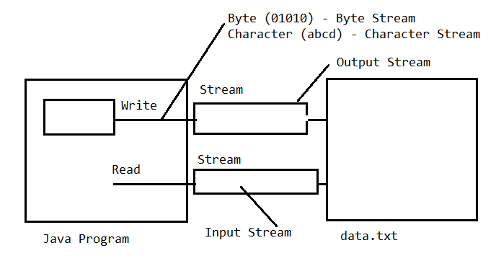

**FileOutput Stream**

* It is used to write data into the destination file from java application. To write data into the .txt file we have to use write () method.

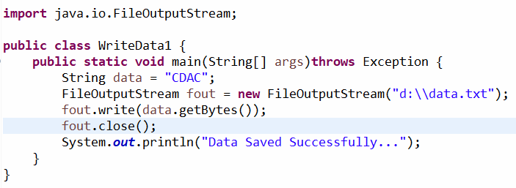

**Assignment#1**

Write a program to read student details(e.g. name, emailid, mobileno, gender, address, state, city, pin) using Scanner and save it into the file (e.g. students.txt).

**FileInputStream**

* It is used to read the data from the destination file to the java application. To read the data from the .txt file we have to use read () method.

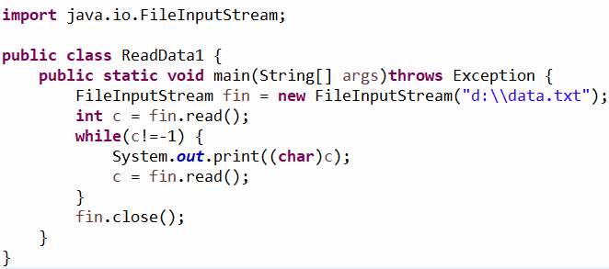

**Assignment#2**

Write a program to read data from the file(e.g. students.txt) and display it

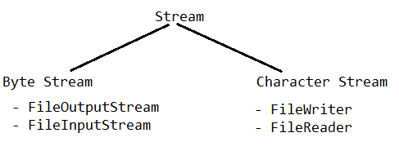

**FileWriter**

* FileWriter class is given for writing character files. Whether or not a file is available or may be created depends upon the underlying platform.

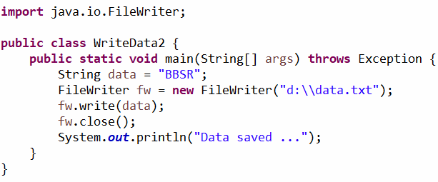

**Assignment#3**

Write a program to read student details(e.g. name, emailid, mobileno, gender, address, state, city, pin) using Scanner and save it into the file (e.g. students.txt).

**FileReader**

* FileReader is a convenience class for reading character files.

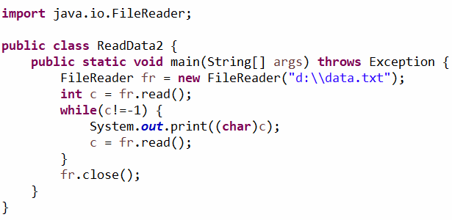

**Assignment#4**

Write a program to read data from the file(e.g. students.txt) and display it

**Assignments#5**

Write a java program to copy a File

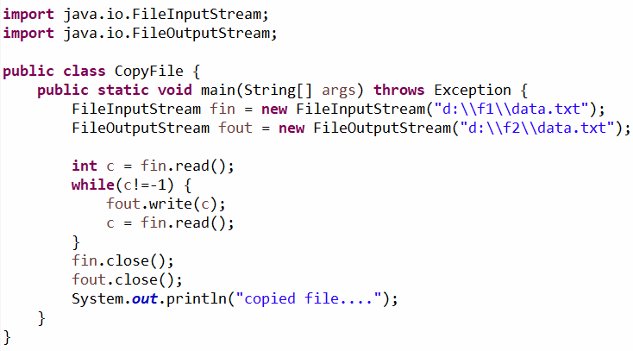

**Assignments#6**

Write a java program to move a File.

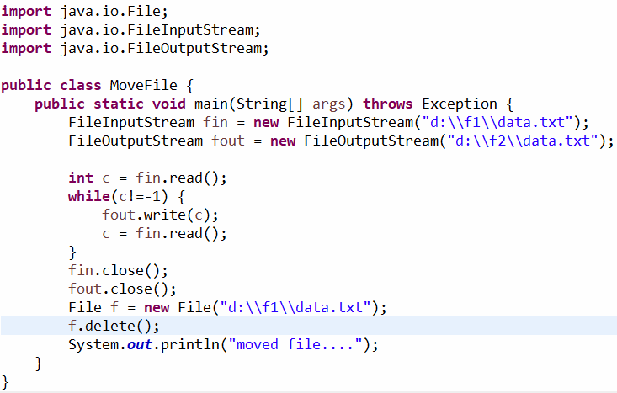

**Assignments#7**

Write a java program to merge files.

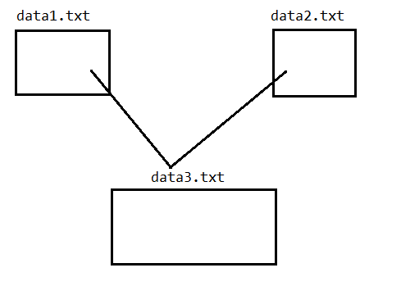

**Serialization**

* The process of writing the state of an object into a file is called serialization.

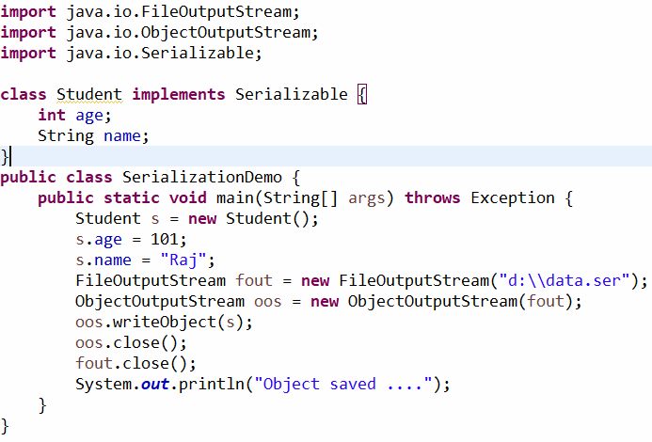

**Deserialization**

* The process of reading the state of an object from a file is called Deserialization.

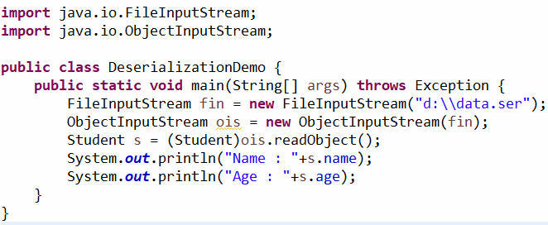

**BufferedReader**

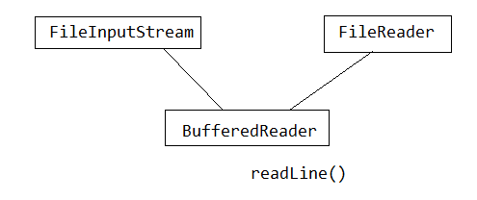

* BufferedReader class is used to read the text from a character based input stream.
* It can be used to read data line by line by readLine () method. It makes the performance fast. It inherits Reader class.

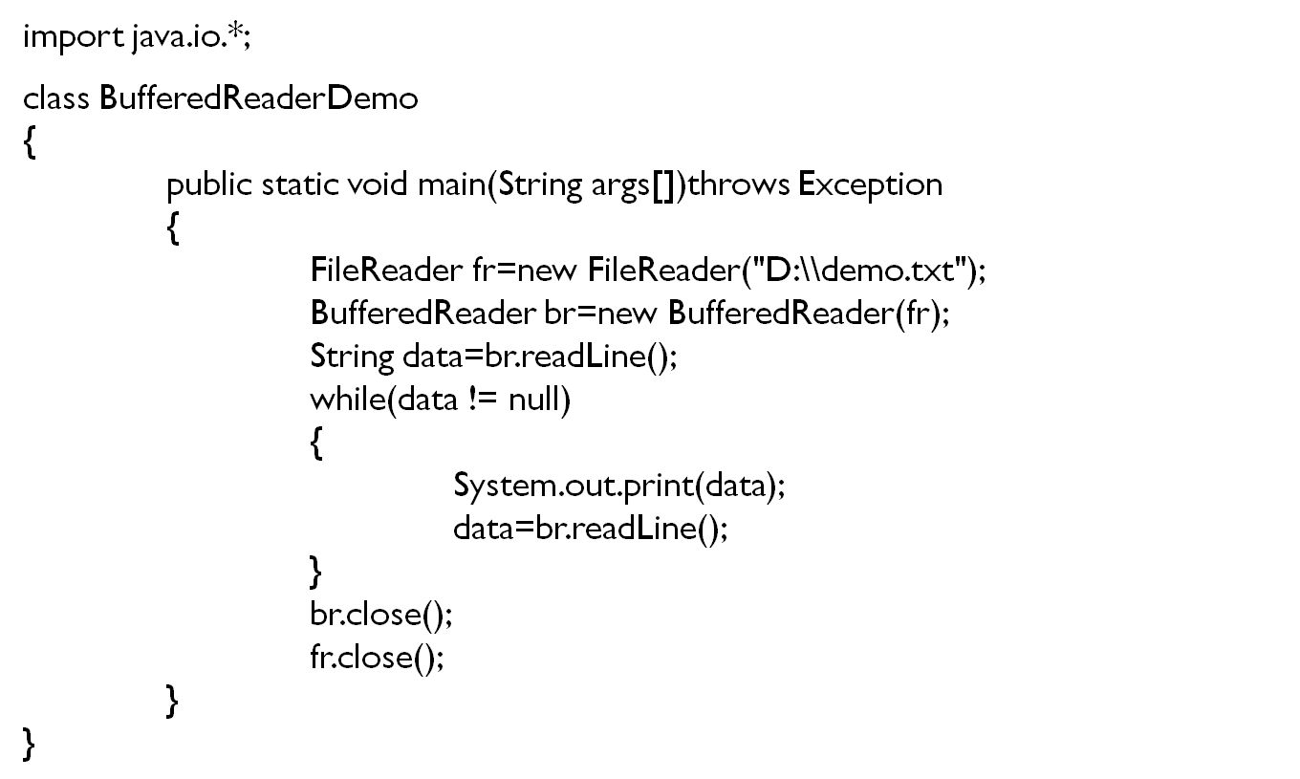

**InputStreamReader**

* An input stream reader is a bridge from byte stream to character stream. It reads byte and decodes them into characters.

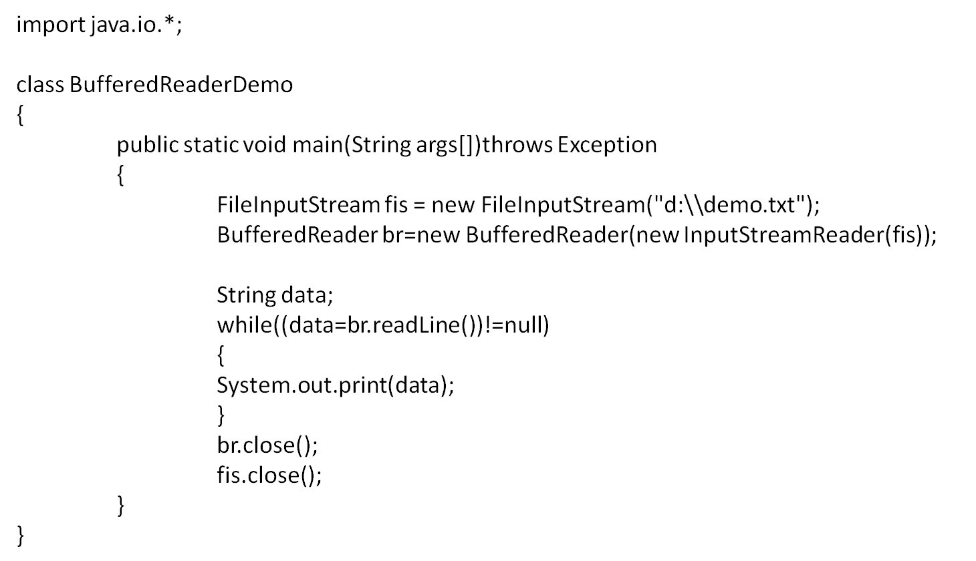

**Reading Data from the Keyboard**

* Using Command line argument
* Using Scanner Class
* Using Buffered Reader
* Using Console

**Reading Data from the Keyboard using BufferedReader**

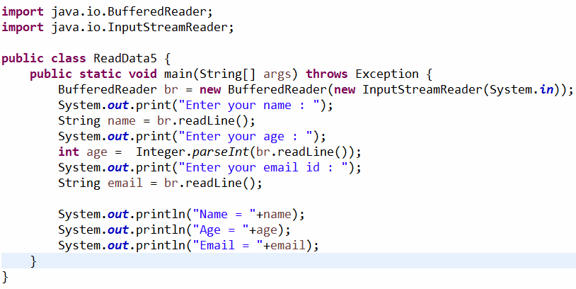

**Reading Data from the Keyboard using Console**

* If an application needs to read a password or other secure data then we should use readPassword () method.

